**Simulation of a Restaurant’s Table Arrangement**

AMS 533 final project report

Linkun Chen, Chenjun Feng, Zhixiu Liang, Saiyang Qi, Yunke Tian, Junao Wang

**Project Introduction**

Simulation modeling is one of the most widely adopted methods for decision making in commercial activities. In this report we will demonstrate how we built up a simulation modeling program and utilized such a program to make a crucial business decision.

Stony Brook Buffet (SBB) restaurant will soon open and the manager needs to make the critical decision for the table arrangement. SBB is able to accommodate at most 40 customers at the same time. There are only two types of tables available. They are four-seat table (a table that can accommodate 4 customers) and two-seat table (a table that can accommodate 2 customers). If we assume that K four-seat tables are placed (0<=K<=10), then we would have (40-4K)/2 two-seat tables accordingly, so that the total number of seats will be 40. The key point here is to find the optimal value of K in order to maximize the daily revenue.

To determine K, it is essential to have a clear picture of the simulation system. Customers randomly come to SBB in groups of 1, 2, 3 or 4 people with the same probability 1/4. Based on our collected data, we found out that the number of arriving groups of customers for every minute within each business hour fits a Poisson distribution (see the data set in Table 1 below). Customers then will be seated according to a modified first-come-first-serve (FCFS) policy. Customers are served group by group. Groups containing 1 or 2 customers will take a two-seat table primarily. If no two-seat table is available for them, they will be seated in a four-seat table if there is any. Otherwise, they have to wait in the queue. Groups containing 3 or 4 customers can only take a four-seat table, and otherwise they have to wait in the queue. For a better customer experience, two groups never share a table, and one group of customers never splits into two. Based on our observation, it is a reasonable assumption that groups of 1, 2, 3 and 4 customers take 20, 30, 35 and 45 minutes to finish their meals respectively. Also, we assume that customers always decide to leave after waiting for 15 minutes in the queue. The business hour of SBB is 11AM to 9PM, and the buffet costs $20/person.

**Data Collection & Input Analysis**

We first collected the raw data from a real buffet restaurant. We recorded the number of arriving groups of customers for every minute during each business hour from 11AM to 9PM. Below is one instance of our data set from noon to 1PM.

**Table 1: Number of Arriving Groups of Customers for Every Minute from Noon - 1PM**

|  |  |  |  |  |  |  |  |  |  |
| --- | --- | --- | --- | --- | --- | --- | --- | --- | --- |
| **Time** | **# of Groups** | **Time** | **# of Groups** | **Time** | **# of Groups** | **Time** | **# of Groups** | **Time** | **# of Groups** |
| 01 | 2 | 13 | 0 | 25 | 1 | 37 | 0 | 49 | 1 |
| 02 | 0 | 14 | 1 | 26 | 2 | 38 | 4 | 50 | 0 |
| 03 | 0 | 15 | 0 | 27 | 1 | 39 | 0 | 51 | 2 |
| 04 | 0 | 16 | 1 | 28 | 2 | 40 | 0 | 52 | 1 |
| 05 | 2 | 17 | 2 | 29 | 1 | 41 | 1 | 53 | 3 |
| 06 | 3 | 18 | 3 | 30 | 1 | 42 | 0 | 54 | 1 |
| 07 | 0 | 19 | 2 | 31 | 2 | 43 | 0 | 55 | 3 |
| 08 | 2 | 20 | 2 | 32 | 1 | 44 | 0 | 56 | 3 |
| 09 | 1 | 21 | 1 | 33 | 2 | 45 | 2 | 57 | 0 |
| 10 | 3 | 22 | 1 | 34 | 1 | 46 | 1 | 58 | 3 |
| 11 | 0 | 23 | 0 | 35 | 2 | 47 | 0 | 59 | 2 |
| 12 | 2 | 24 | 1 | 36 | 1 | 48 | 0 | 60 | 0 |

Based on the data above, the histogram can be generated accordingly (see Fig. 1 below). Considering the shape of the histogram, we hypothesized that the data set from Noon to 1PM would fit a Poisson distribution. In fact, we got similar histograms for other business hours as well. Therefore, we hypothesized that they all fit Poisson distributions with different parameter ʎ values. We then calculated their parameters using maximum likelihood estimation 

**Fig. 1: Distribution of Arrival Groups of Customers from Noon - 1PM**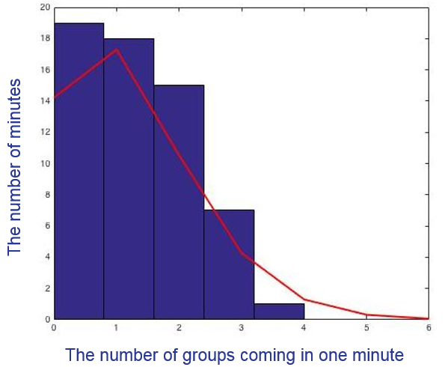

Finally, chi-square tests were taken to check the goodness of fit. Table 2 below shows that for most of time, poisson distributions are ideal for our simulation modeling.

**Table 2: Chi-square Tests for Each Business Hour and the Respective Results**

|  |  |  |  |  |
| --- | --- | --- | --- | --- |
| **Time Period** | **Parameter ʎ** | **Chi-square Value** | **Critical Value(4, 0.95)** | **H0** |
| 11AM - Noon | 0.424 | 5.1478 | 9.488 | ✓ Accept |
| Noon - 1PM | 1.16 | 0.6564 | 9.488 | ✓ Accept |
| 1PM - 2PM | 0.652 | 3.2013 | 9.488 | ✓ Accept |
| 2PM - 3PM | 0.348 | 1.9968 | 9.488 | ✓ Accept |
| 3PM - 4PM | 0.276 | 9.5236 | 9.488 | ☓ Reject |
| 4PM - 5PM | 0.652 | 1.6429 | 9.488 | ✓ Accept |
| 5PM - 6PM | 0.972 | 1.4587 | 9.488 | ✓ Accept |
| 6pm - 7pm | 1.24 | 0.9762 | 9.488 | ✓ Accept |
| 7PM - 8PM | 1.06 | 2.4382 | 9.488 | ✓ Accept |
| 8PM - 9PM | 0.652 | 4.9078 | 9.488 | ✓ Accept |

**Simulation Modeling Program in MATLAB®**

We performed our simulation modeling via MATLAB with several carefully coded subroutines to simulate the operations of SBB.

Subroutine 1 - Random Variates Generator: using random numbers to generate random variates of groups of coming customers with the input Poisson distributions.

Subroutine 2 - Queueing Handler: arranging the queue according to the modified FCFS policy, and removing customers who have waited for more than 15 minutes.

Subroutine 3 - Seat Handler: deciding if there is an empty table with the proper size (two seats or four seats) for a group of customers from the head of the queue to the end.

Subroutine 4 - Table Recorder: recording the tables, the change of seating status, and the customers’ eating time.

Subroutine 5 - Revenue Calculator: calculating daily revenue with respect to different K values.

**Output Analysis & Conclusion**

It is apparent that our project is a terminating simulation. The initial status occurs at 11AM when SBB is empty. The stopping event happens at 9PM when no more customer is allowed to come into the restaurant.

Let’s recall that K stands for the number of four-seat tables in SBB. Because the total seating space in SBB is 40, then the K value ranges from 0 to 10, and the number of two-seat table is (40-4K)/2. For each K, we ran our simulation program 1,000 times to acquire 1,000 values of daily revenue. The average of the 1,000 daily revenue then was plotted into Fig. 2 below. We repeated the same process for every K value.

**Fig. 2: Average Revenue with Different K Fig. 3: Trend of Variance with K=5**

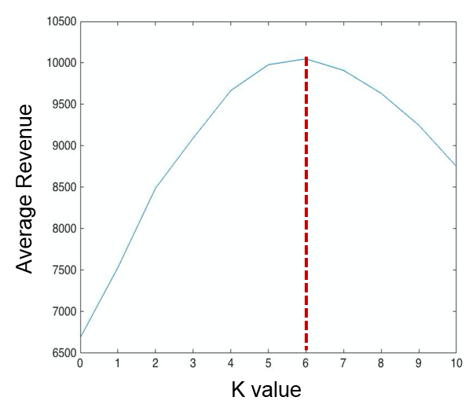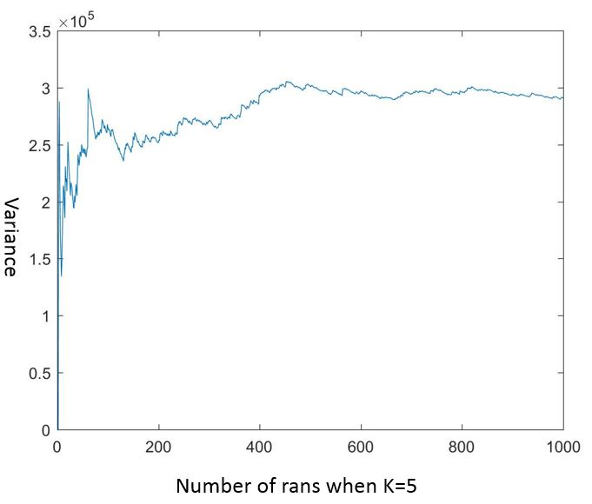

The reason why we decided to run the program 1,000 times is to minimize the variance. As Fig.3 shows, when K is 5, the variance tends to be relatively stable after the program is ran more than 800 times. Similar trends can be found for other K values as well.

Fig. 2 tells a lot of information. When K is 0 meaning there is no four-seat table and all tables are two-seat, the daily revenue will be the lowest. This makes sense because SBB would lose all the groups of 3 or 4 customers (Splitting a group of customers is not allowed). On the other hand, when K is 10 meaning all tables are four-seat and there is no two-seat table, the daily revenue is also pretty low. This is because the groups of 1 or 2 customers have to take a four-seat table, leading to the waste of 3 or 2 empty seats (Sharing a table is not allowed). This eventually causes less income.

Fig. 2 clearly shows that when K is 6, the daily revenue reaches the highest point. This is a key value. It indicates that when there are 6 four-seat tables and 8 two-seat tables in SBB, the daily revenue will be maximized. Therefore our simulation successfully found out the optimal table arrangement in SBB restaurant.

**Future Work**

Due to limited time and resources, some operating conditions of SBB are simply based on our assumptions and observations. In the future, more random variates could be used to better simulate the system. For example, the customers’ eating time could be random, the time for which one customer is willing to wait for in the queue could be random, the number of customers in a group could be increased to more than 4, more types of tables could be considered (Ex: 6-seat table) and etc.

**Reference**

Averill M. Law, Simulation Modeling and Analysis (5th edition), *McGraw Hill Higher Education* (February 1, 2014) ASIN: B0108DF5Q2